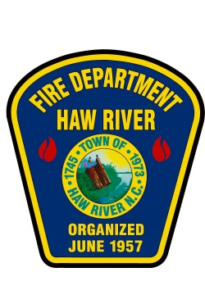
Notice of Employment
Town of Haw River Fire Department
The Town of Haw River Fire Department is now accepting applications for the position of:
Part-Time Firefighter/Driver Operator/EMT
Rate of Pay: $15.00 per hour
Shift: 12 Hours
Application Process:
The Haw River Fire Department will be accepting applications for the position of part time firefighter. The application process will remain open in order to create a continuous hiring pool for the department. Applications can be found online on the Town’s website at www.townofhawriver.com or they may be picked up at the Haw River Town Hall located at 403 E. Main St., Haw River, NC 27258. A resume must be included with each application.
All application packets should be submitted to the Fire Chief, located at the Haw River Fire Department, 403 E. Main St. (PO Box 142), Haw River, NC 27258. Phone 336-578-1355
Position Summary:
Applicants will be required to work on designated shifts and provide fire suppression, emergency medical care and driver operator knowledge, skills and abilities. Applicants should possess a strong knowledge of emergency vehicle operations and be capable of adequately managing a fire scene. Applicants should be self-motivated with a strong sense of personal accountability.
Position Requirements:
All applicants must meet the following requirements to be considered for the position:
- NC Certified Firefighter
- NC Certified EMT-B or higher
- At least 21 years of age
- Adequate driver operator skills
- A valid NC class B driver’s license
The Town of Haw River is an equal opportunity employer.
It is the policy of Town of Haw River to prohibit discrimination on the basis of race, gender, creed, national origin, religion, age, or disability in employment or the provision of services.

